Host header authentication bypass
Lab Report
Prepared by: Nihar Mane

INDEX
1. Report Metadata....................................................................................................................................….2
2. Executive Summary...................................................................................................................................2
3. Scope......................................................................................................................................................... 3
4. Methodology and Root Cause..................................................................................................................3
5. Step-by-Step Execution........................................................................................................................... 4
Step 1—Capture the baseline request.................................................................................................................... 4
Step 2—Inspect the Host header............................................................................................................................ 4
Step 3—Confirm baseline behavior......................................................................................................................... 5
Step 4—Browse the robots.txt to find the hidden admin path................................................................................. 6
Step 5—Discover the hidden /admin path............................................................................................................... 6
Step 6—Attempt direct access to /admin................................................................................................................. 7
Step 7—Access denied by an origin-based restriction............................................................................................ 8
Step 8—Send the /admin request to Repeater........................................................................................................ 8
Step 9—Confirm the restricted response in Repeater............................................................................................. 9
Step 10—Poison the Host header to bypass the restriction.................................................................................. 10
Step 11—Use the exposed panel to delete the target user................................................................................... 10
6. Impact Assessment................................................................................................................................. 11
7. Remediation............................................................................................................................................. 11
8. Conclusion............................................................................................................................................... 12
References................................................................................................................................................... 12

1. Report Metadata
Lab Name | Host header authentication bypass
Provider | PortSwigger Web Security Academy
Vulnerability class | Host header validation bypass → broken access control → administrative function exposure
Difficulty | Apprentice
Target | PortSwigger Web Security Academy training instance
Tools used | Burp Suite Community Edition v2026.7.2, Burp's built-in browser
Test account | None used—the bypass requires no credentials.
Target account | Carlos (deleted via the exposed admin panel)
Date tested | 5 August 2026

2. Executive Summary
This engagement targeted the “Host header authentication bypass” lab on the PortSwigger Web Security Academy. The application decides whether a request is allowed to reach its administrative interface by checking the value of the client-supplied Host header, rather than the real origin of the connection. A request is treated as coming from a trusted “local” source if its Host header simply reads localhost, and the admin panel is unlocked on that basis alone.
Because the Host header is entirely controlled by the client, this check can be defeated without any credentials. The lab's /admin path was first discovered through robots.txt, which explicitly disallowed it—a strong signal that something sensitive lived there. Requesting /admin directly returned an HTTP 401 response with the message “Admin interface only available to local users.” The same request was then replayed in Burp Repeater with the Host header changed to localhost. The server responded 200 OK and rendered the full administrative panel.
From inside that panel, a request was sent to delete the user carlos (GET /admin/delete?username=carlos). The application returned a 302 redirect, and the lab was marked “Solved.” No password, session token, or valid credential of any kind was needed—the entire access-control decision rested on a single header the attacker fully controls.

3. Scope
● In scope: the application's home page, the robots.txt file, the /admin interface, and its user-deletion function on the Web Security Academy lab instance.
● Out of scope: everything outside the lab environment, PortSwigger's underlying infrastructure, and any system not provided as part of the training exercise.
● Testing was performed on a lab instance of PortSwigger Provisions specifically for this exercise. No real accounts, credentials, or production systems were involved at any point.

4. Methodology and Root Cause
This is a host-header-based access-control flaw. The application infers a caller's privilege level—specifically, whether the request is “local” and therefore trusted—from the client-supplied Host header, instead of the actual network path the request took (the real client IP, a mutual-TLS certificate, or a network-layer control such as binding the admin listener to loopback only).
Nothing downstream validates the Host header against the connection's true origin, so any client can simply claim to be localhost and be treated as an internal, trusted caller. Because that trust decision guards a real administrative function—including the ability to delete users—the impact of forging one header is a full authentication bypass on the admin panel.
The methodology followed was
● Captured the baseline home page request in Burp Proxy and sent it to Repeater to confirm normal application behavior.
● Reviewed the lab's own description and a walkthrough for context, then probed for hidden functionality by requesting /robots. txt.
● Found an explicit Disallow: /admin entry in robots.txt, revealing a hidden administrative path not linked anywhere on the site.
● Requested /admin directly in the browser and confirmed it was blocked by an origin-based restriction rather than a login form.
● Located the GET /admin request (HTTP 401) in Burp Proxy's HTTP History and sent it to Repeater for header manipulation.
● Replayed the request unmodified in Repeater to confirm the exact 401 response the bypass needed to defeat.
● Changed the host header to localhost and resent the request, gaining full access to the admin panel.
● Used the exposed panel to submit a destructive action—deleting the user Carlos—to prove the bypass allows real administrative impact, not just a page view.

5. Step-by-Step Execution
Step 1-Capture the baseline request.
The home page request (GET /) was captured in Burp Proxy's HTTP History and sent to Repeater, establishing a starting point for testing the Host header.
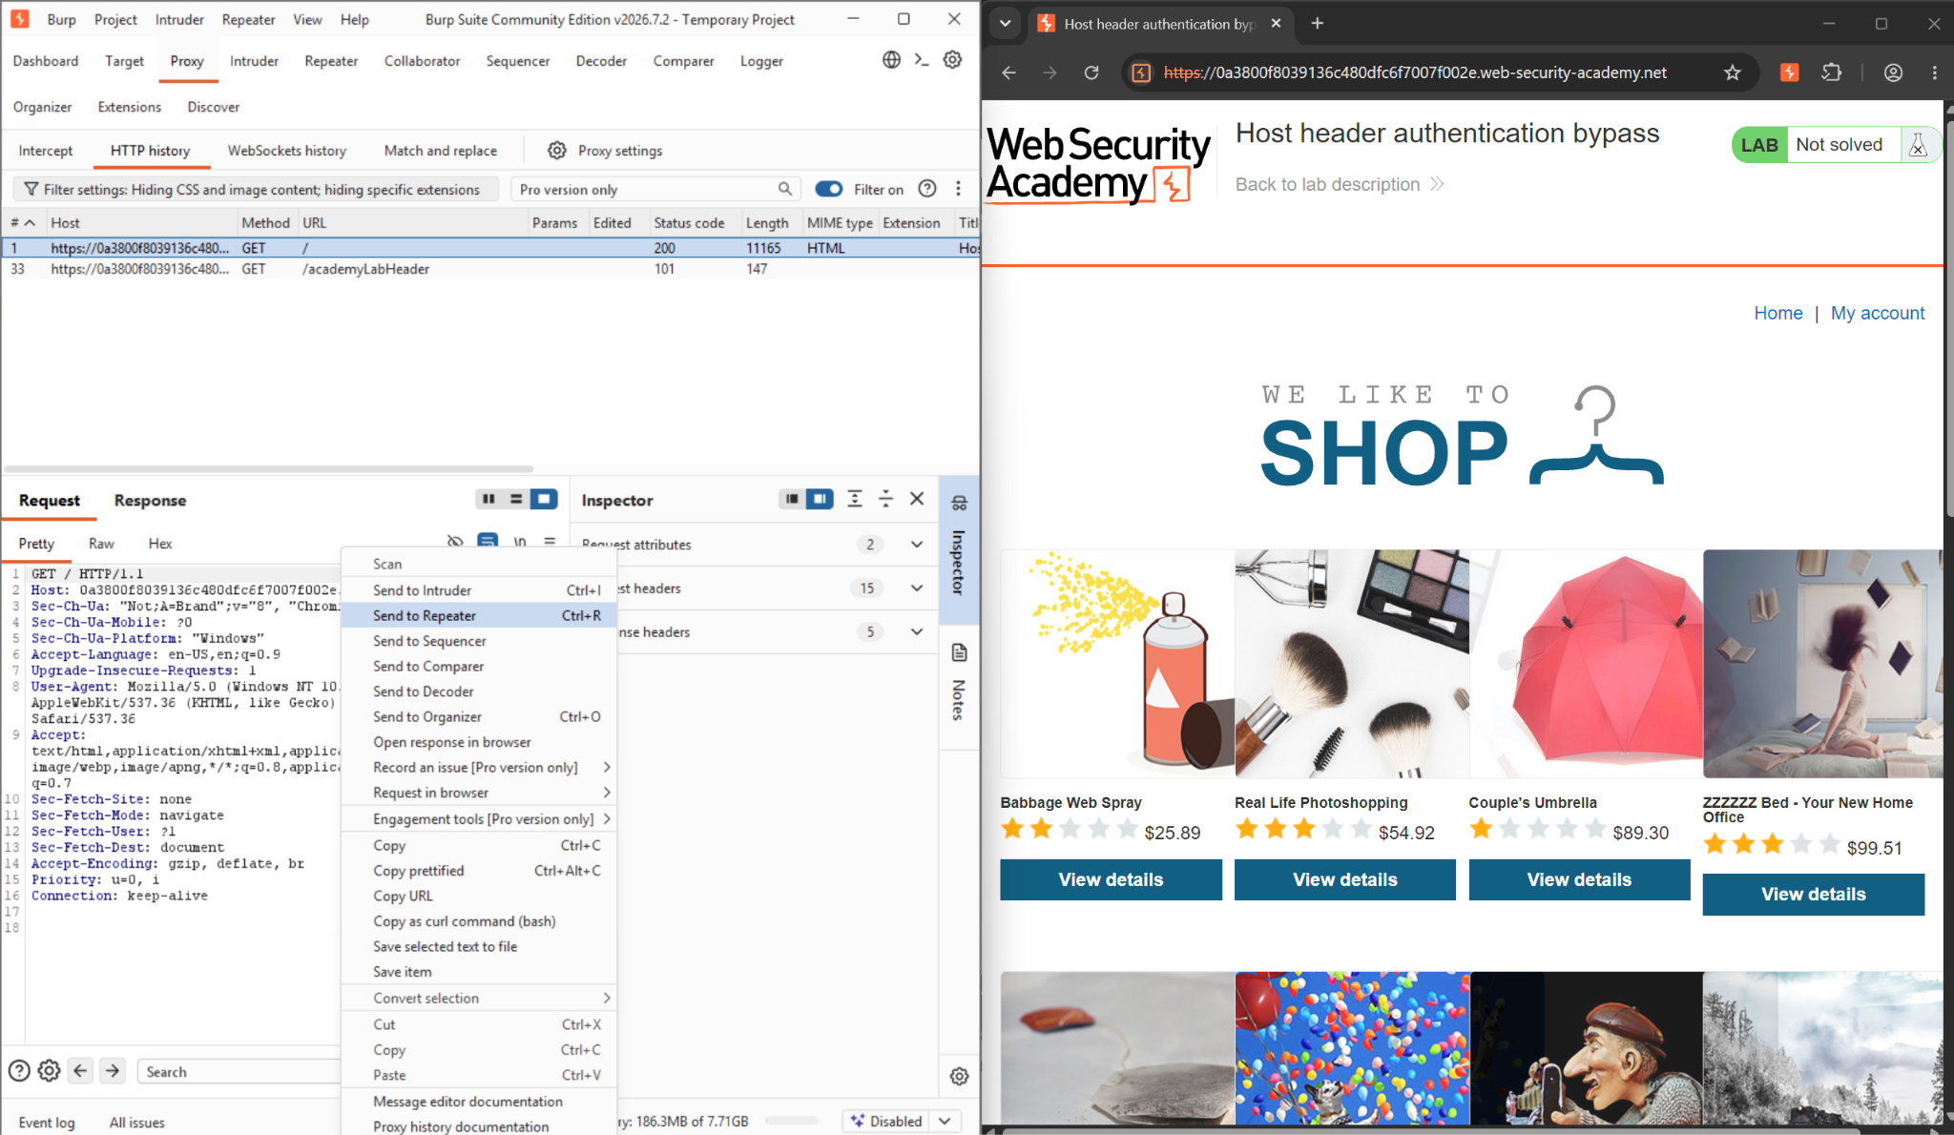
Figure 1: Burp Proxy HTTP History with the baseline GET / request selected and sent to Repeater

Step 2—Inspect the Host header.
In Repeater, the Inspector panel was used to examine the Host header field in detail before modifying it, confirming exactly what value the application expected.

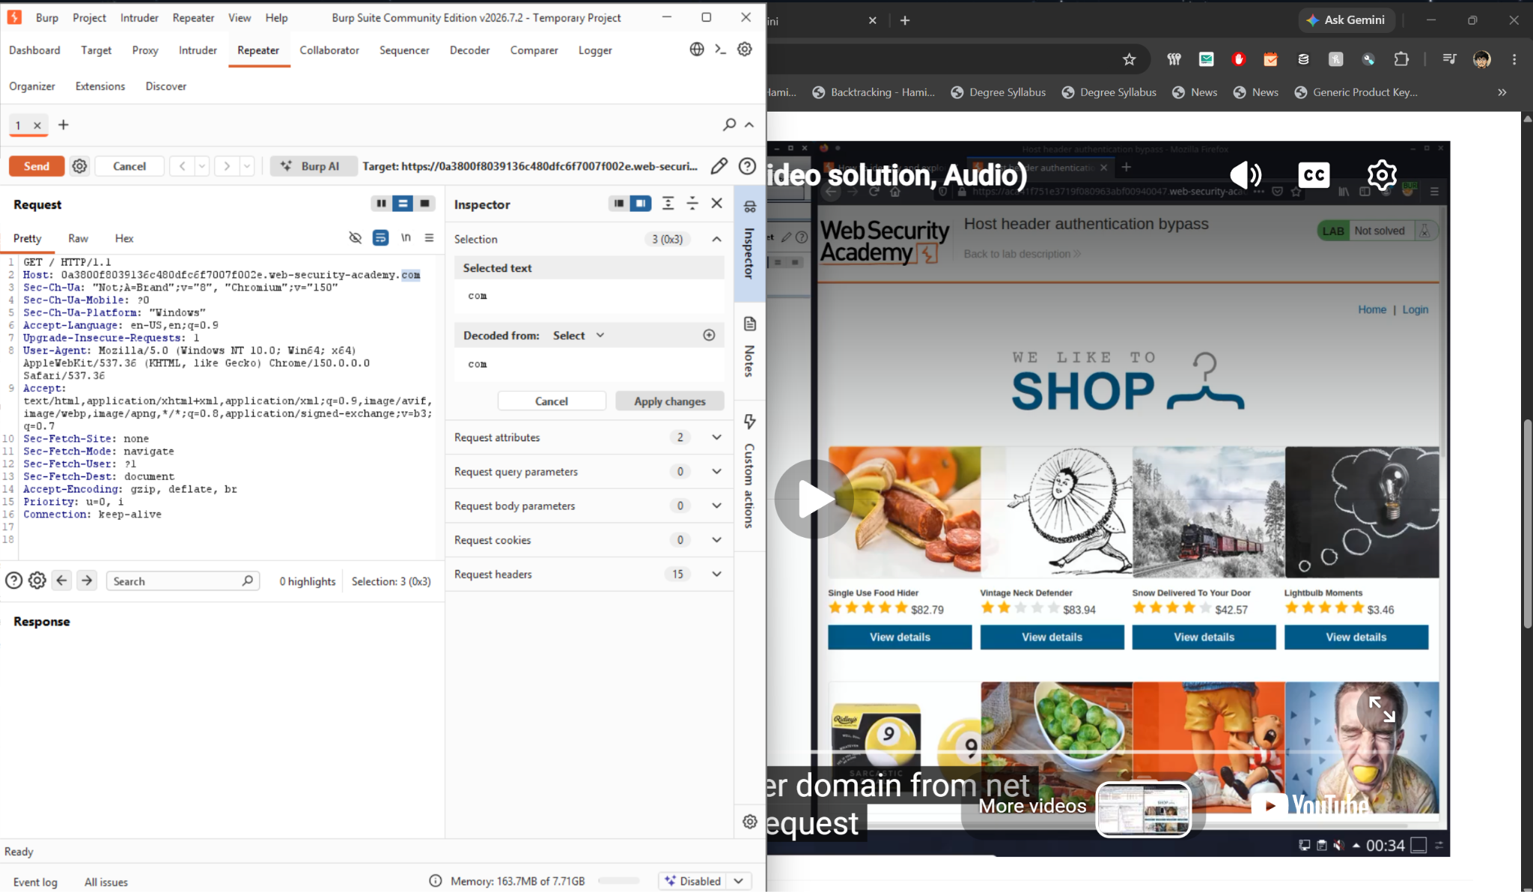
Figure 2: Repeater Inspector panel with the Host header value selected for review

Step 3- Confirm baseline behavior.
The unmodified request was sent and returned a normal 200 OK response for the home page. This established what “expected” behavior looked like before any tampering began.

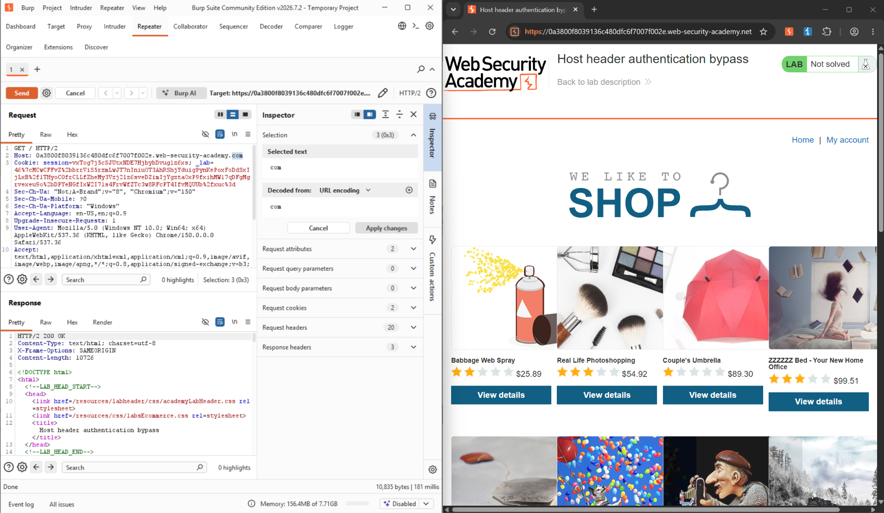
Figure 3: Repeater showing a 200 OK response to the unmodified baseline request
Step 4—Browse the robots.txt to find the hidden admin path.
We enter /robots.txt in the path to find the hidden admin.
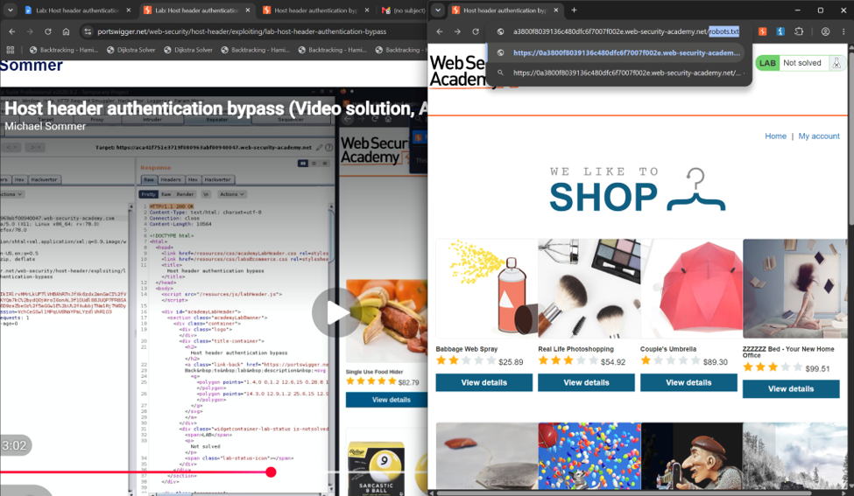
Figure 4: Browser navigating to /robots.txt
Step 5- Discover the hidden /admin path.
robots.txt returned a Disallow: /admin rule. Disallowed entries are meant to keep search engines away from a path—they are not access controls—so this directly revealed the location of the administrative interface.

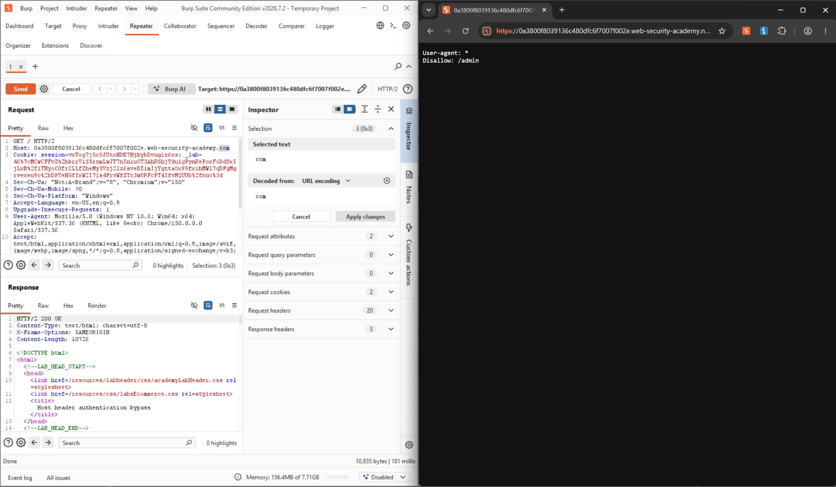
Figure 5: robots.txt content revealing a disallow rule for /admin

Step 6- Attempt direct access to /admin.
The browser was pointed directly at /admin to see how the application would respond to an unauthenticated request for the administrative interface.

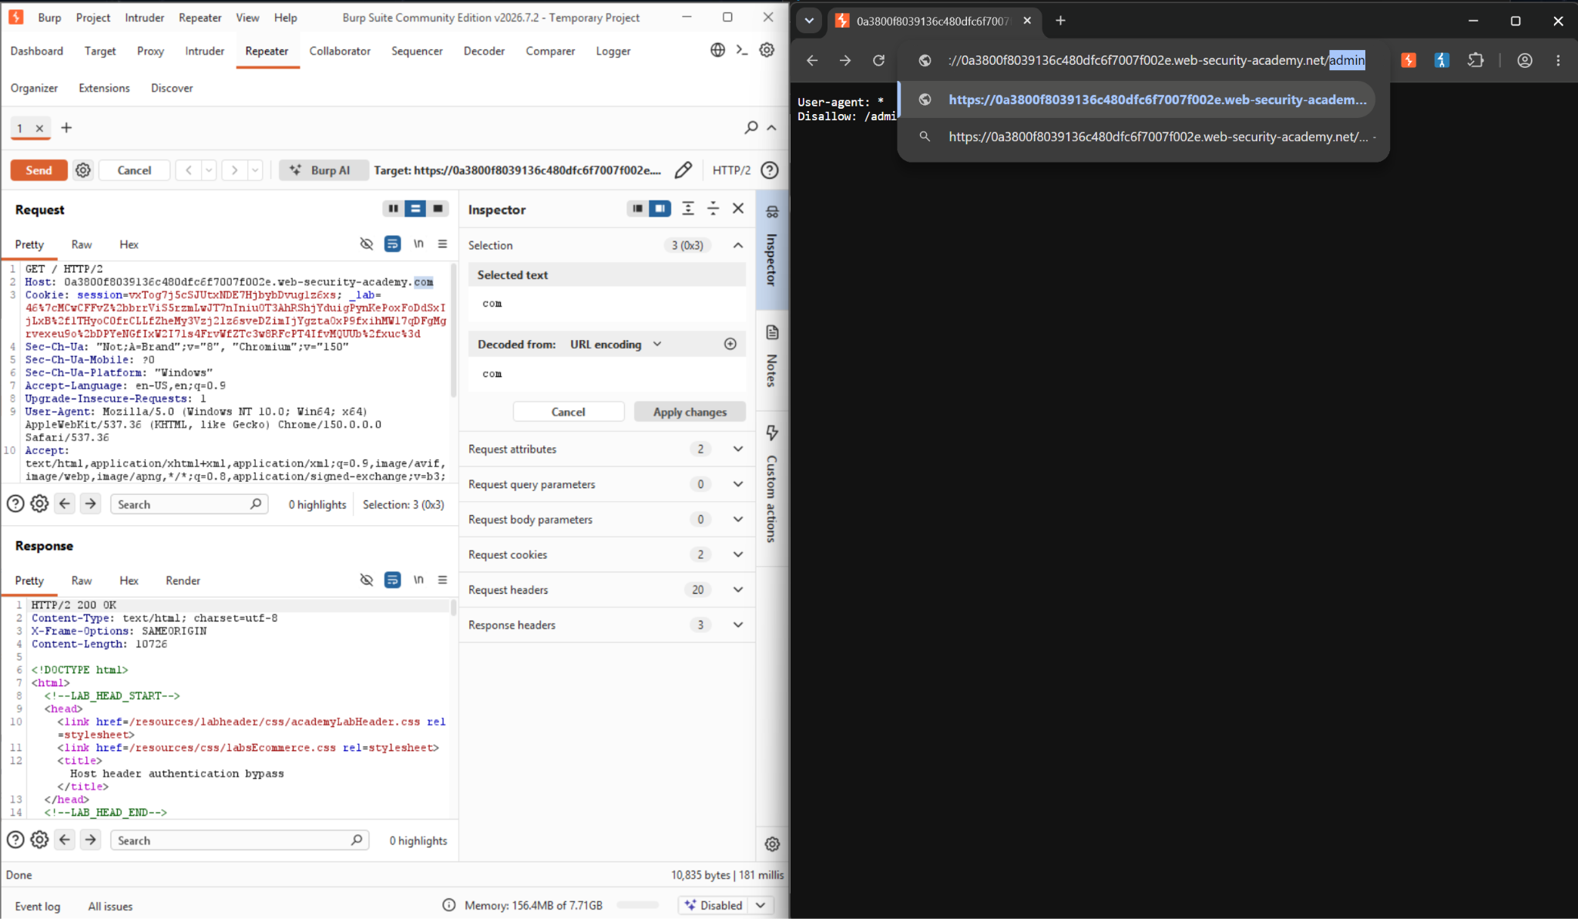
Figure 6: Browser navigating directly to the /admin path
Step 7- Access denied by an origin-based restriction.
The application returned “Admin interface only available to local users.” This response is significant: it is not a login form, which means the restriction is not based on authentication at all—it is based on where the application believes the request came from.

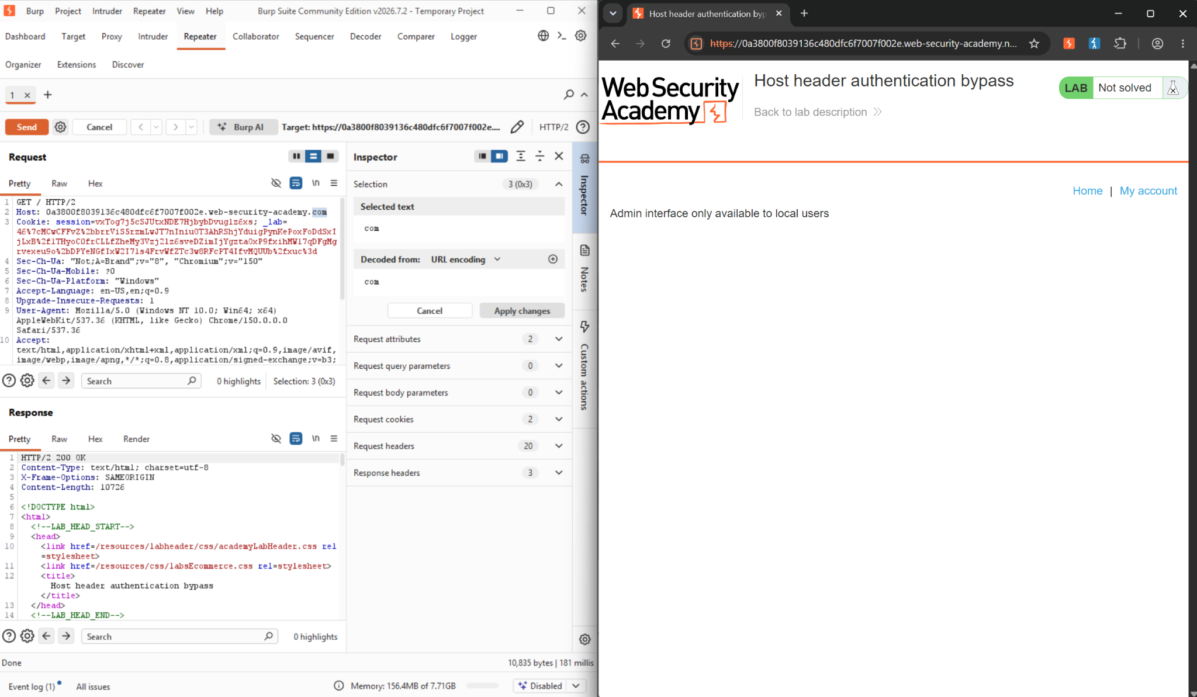
Figure 7: Application response confirming the admin panel restricts access to “local users” rather than requiring login
Step 8- Send the /admin request to Repeater.
The GET /admin request was located in Burp Proxy's HTTP History (HTTP 401, 2,776-byte body) and sent to Repeater, isolating it for controlled header manipulation.

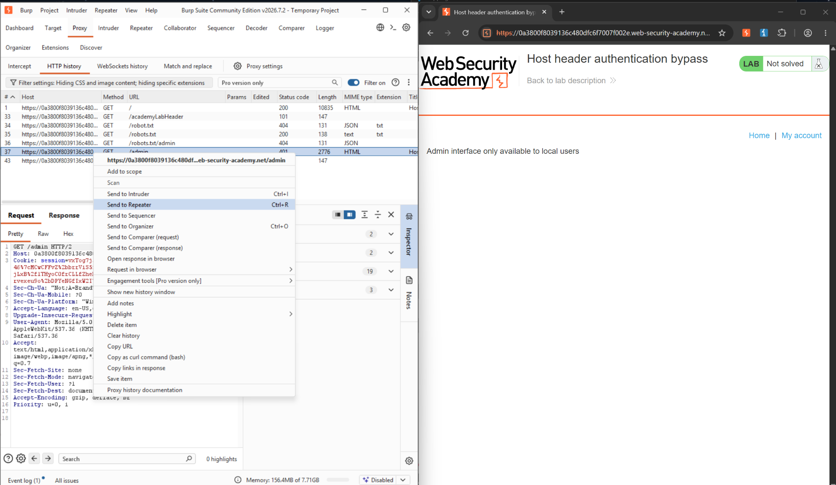
Figure 8: Burp Proxy HTTP History with the 401 GET /admin request selected and sent to Repeater

Step 9- Confirm the restricted response in Repeater.
Replaying the request unmodified reproduced the same HTTP/2 401 Unauthorized response and restriction message, confirming exactly which response the Host header change would need to defeat.

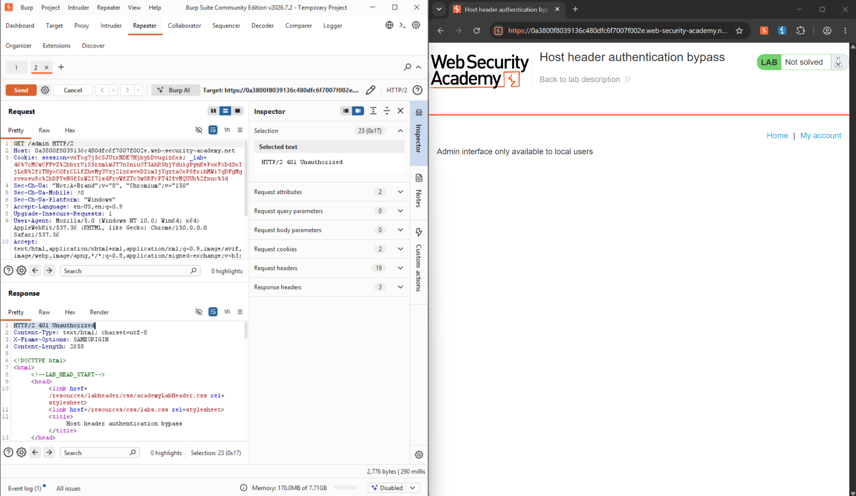
Figure 9: Repeater reproducing the 401 Unauthorized response for the unmodified /admin request
Step 10- Poison the Host header to bypass the restriction.
The Host header was changed from the real lab domain to localhost, and the request was resent. The server returned 200 OK and rendered the full administrative panel—the access-control check had accepted a self-declared header as proof of trusted origin.

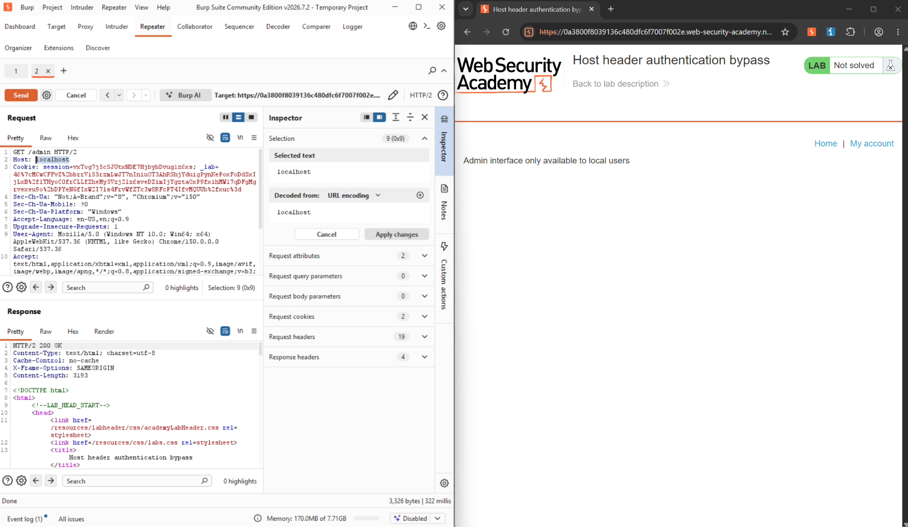
Figure 10: Repeater request with Host header changed to localhost, returning 200 OK and the admin panel

Step 11- Use the exposed panel to delete the target user.
From the now-accessible admin panel, a request was sent to delete the user carlos (GET /admin/delete?username=carlos). The application returned a 302 redirect back to /admin, and the lab banner changed to “Solved,” confirming the bypass allowed a real administrative action, not just a page view.

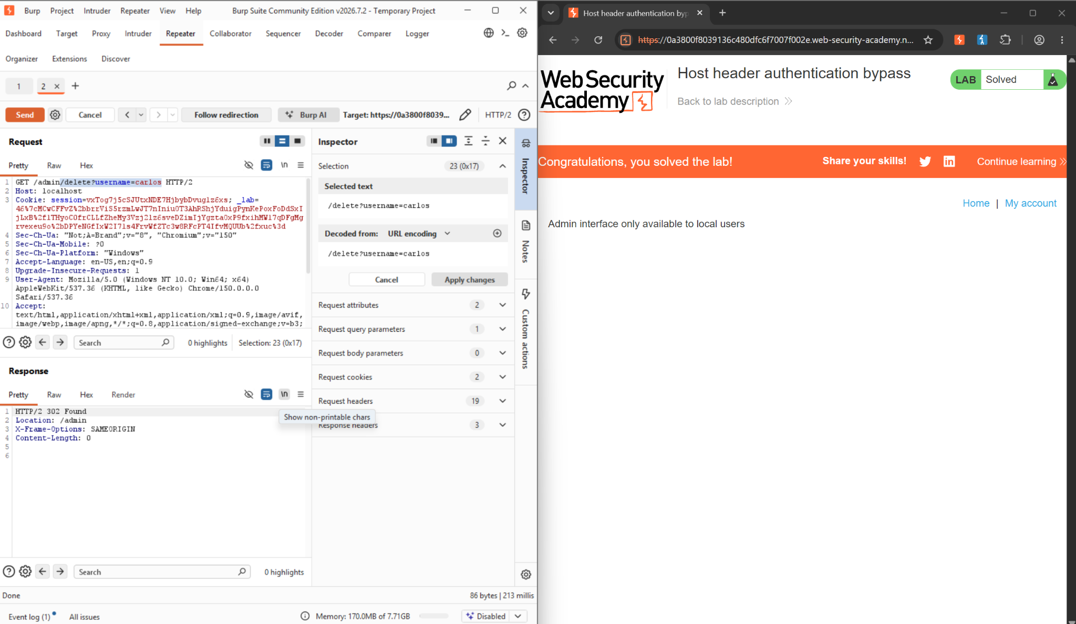
Figure 11: Delete-user request for carlos returning a 302 redirect, with the lab marked “Solved”

6. Impact Assessment
This flaw lets anyone reach the site's admin panel without logging in and without knowing any password. All an attacker has to do is change one line in their request—the Host header—to say localhost. The server then treats them like a trusted internal user.
This is more severe than a typical credential-based flaw because there is no token to steal and no email to intercept first, and no user interaction is needed at all. A single crafted request goes straight to a working admin panel. From there, an attacker can do whatever the panel allows; in this lab, that meant permanently deleting a user account with one request. In a real application, an admin panel usually allows far more: changing settings, viewing other users' data, creating new admin accounts, or disabling security controls entirely.
Because this bypass needs no credentials and no waiting on a victim, it could be scripted and run against many targets in seconds. This was proven end-to-end in the lab—including a real destructive action against a named account—so this is a demonstrated, exploitable issue, not a theoretical one.

7. Remediation
● Never make access-control decisions based on the client-supplied host header. It is attacker-controlled and must not be treated as a trust signal.
● If an application genuinely needs to distinguish “internal” traffic, enforce it at the network layer—for example, bind the admin interface to a loopback-only listener, place it on a separate internal-only virtual host, or have a reverse proxy/firewall strip and overwrite the Host header before it reaches the application—rather than trusting anything the client sends.
● Require full authentication (and ideally MFA or IP allow-listing) for administrative interfaces in addition to any network-level restriction; access control should never rest on a single header.
● Validate the Host header against a strict allow list of the application's real, expected domains, and reject requests carrying unrecognized values outright.
● Apply least privilege to sensitive actions inside the admin panel itself—destructive actions such as user deletion should require re-authentication or an explicit confirmation step, so a bypassed outer gate cannot cause irreversible damage in a single request.
- Log and alert on requests where the Host header does not match the application's expected domain, particularly on sensitive paths such as /admin.

8. Conclusion
This exercise showed how a single trusted-but-unvalidated header can undo an entire access-control layer. The core issue was found in Steps 1 to 7: the application used the client-supplied Host header, rather than the request's real origin, to decide whether a caller was a trusted local user, and it exposed a hidden /admin path referenced only in robots.txt.
Steps 8 to 11 used this issue to reach the admin panel and delete carlos's account. This was done by replaying the blocked /admin request in Repeater with the Host header changed to localhost, which the server accepted as proof of trusted origin. From inside the resulting panel, a delete request was sent for carlos, and the lab was marked Solved.
The lab's solved status and the successful account deletion prove this issue is real and exploitable, not theoretical. No password, session, or victim interaction was ever needed—changing one request header was enough. The core lesson mirrors the password reset poisoning lab tested previously: a client-controlled header is not a safe basis for a security decision. Trust should come from something the client cannot simply declare—a real authentication check or a control enforced at the network layer that the application itself cannot be talked out of.

References
1. PortSwigger Web Security Academy — Host header authentication bypass. https://portswigger.net/web-security/host-header/exploiting/lab-host-header-authentication-bypass
2. PortSwigger — HTTP Host header attacks (background reading). https://portswigger.net/web-security/host-header
3. PortSwigger — Repeater. https://portswigger.net/burp/documentation/desktop/tools/repeater/http-messages
4. PortSwigger — Proxy HTTP History. https://portswigger.net/burp/documentation/desktop/tools/proxy/http-history
5. PortSwigger Web Security Academy — Basic password reset poisoning (companion lab, same Host-header trust class). https://portswigger.net/web-security/host-header/exploiting/password-reset-poisoning/lab-host-header-basic-password-reset-poisoning

